:

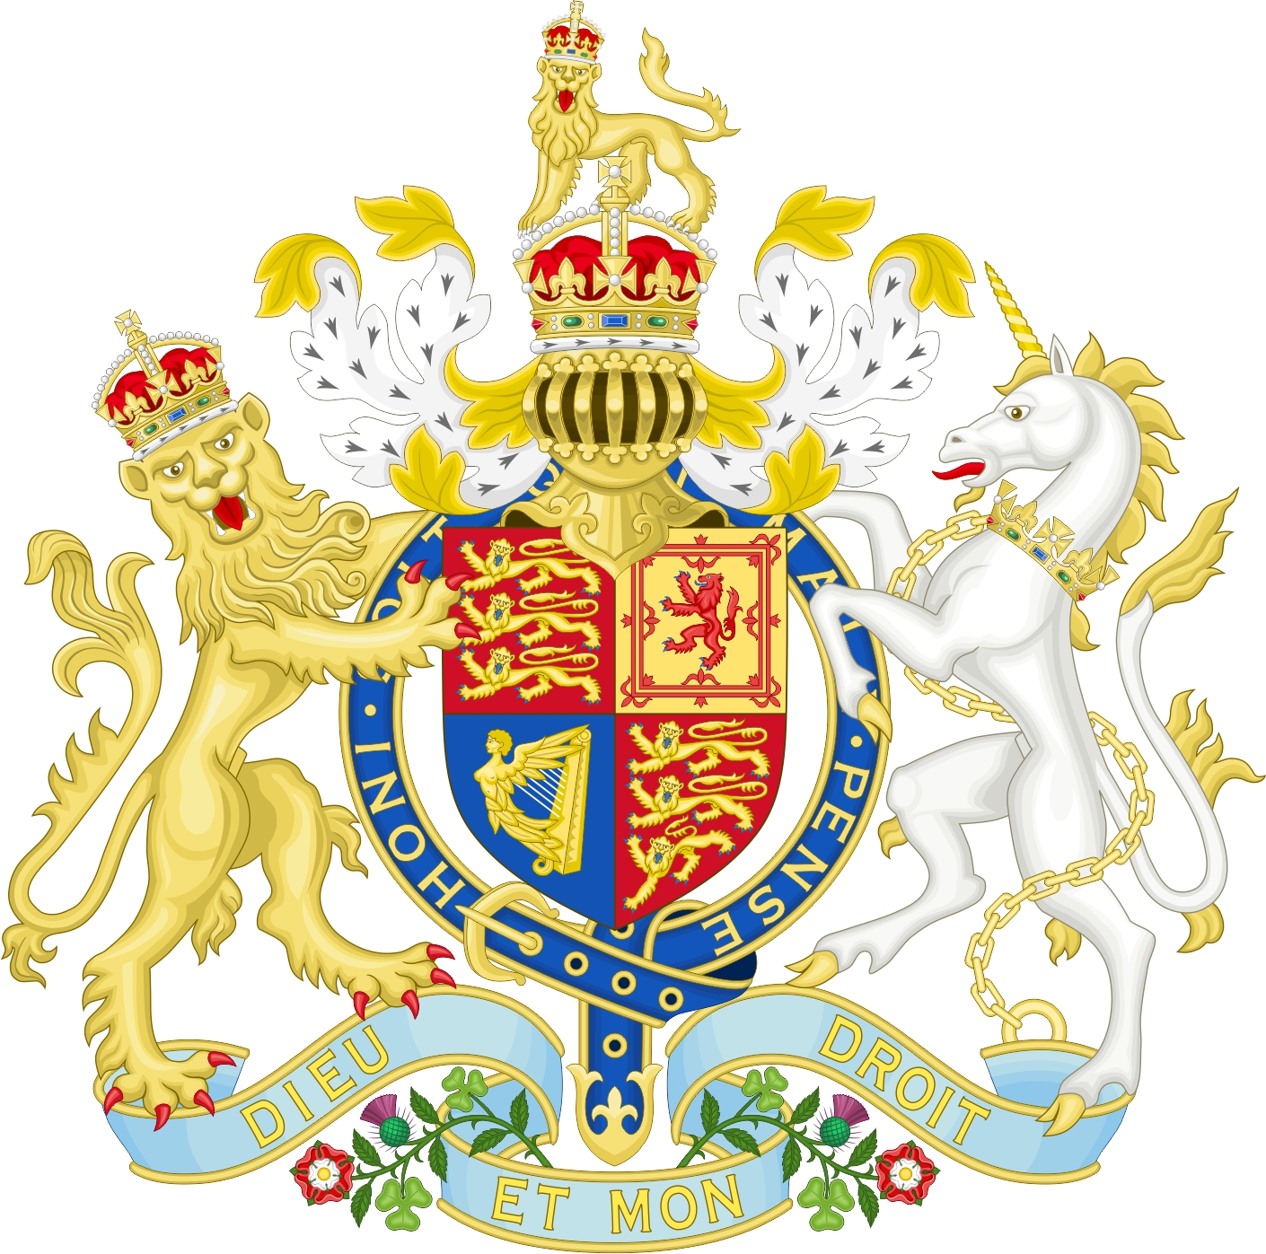

I, Josephine, born of the family Bloggs, do swear that I will be faithful and bear true allegiance to His Majesty King Charles III, his heirs and successors, according to law. So help me God.

By signing this document and swearing the above Oath, I am stating, that I am now and will remain, part of the Commonwealth of Australia.

I am a Living Wo/man and Not a Legal Fiction.

To deal with me you must be dealing in Common Law under the Authority of our Commonwealth of Australia Constitution Act 1900, not the unlawful Annotated Constitution of the Australian Commonwealth, Revised Edition.

Autograph ……………………………………………………

Dated this …………………….... Day of the Month of ………………………., in the Year 2023

Witness one autograph …………………………………………………………….

Witness two autograph …………………………………………………………….